InsightStream Navigate the news landscape – Frontend Documentation

# 1. Project Title

InsightStream Navigate the news landscape – Frontend Module  
  
Team ID: NM2025TMID40747  
Team Leader: Gokula kannan .M - nobitanobita5750@gmail.com  
Team Members:

* Kishore .V - kishore.v6789@gmail.com
* Maharaja .C - rajamaha72233@gmail.com
* Munieswaran .U - munishnaveen350@gmail.com

# 2. Project Overview

Purpose:  
The News Web App frontend provides a user-friendly interface for browsing and reading the latest news articles fetched from APIs or local data.  
  
Frontend Features:  
- Landing page with headlines and categories  
- Filter news by category or search term  
- Responsive navigation bar and footer  
- Fast-loading interface built with React  
- Mobile and desktop friendly UI

# 3. Architecture (Frontend)

- Framework: React.js  
- Styling: CSS/Tailwind CSS (depending on project setup)  
- Data Source: News API integration or static JSON data  
- Component-based architecture for reusability

# 4. Setup Instructions

Prerequisites:  
- Node.js (latest LTS)  
- npm (comes with Node.js)  
- Code editor (VS Code)  
  
Installation Steps:  
# Clone the repository  
git clone <repository-url>  
cd news-app  
  
# Install dependencies  
npm install  
  
# Start development server  
npm start  
  
Access:  
Open http://localhost:3000 in browser

# 5. Folder Structure (Frontend Only)

news-app/  
 ├── public/  
 │ ├── index.html  
 │ ├── favicon.ico  
 │ ├── manifest.json  
 │ └── robots.txt  
 ├── src/  
 │ ├── index.js  
 │ ├── App.js  
 │ ├── App.css  
 │ ├── index.css  
 │ ├── components/  
 │ │ ├── NavBar.jsx  
 │ │ ├── NewsList.jsx  
 │ │ ├── NewsItem.jsx  
 │ │ └── Footer.jsx  
 │ ├── pages/  
 │ │ ├── Home.jsx  
 │ │ ├── Category.jsx  
 │ │ └── ArticleDetail.jsx  
 │ ├── styles/ (if any)  
 │ └── assets/ (images/icons)

# 6. Running the Application

- Start frontend:  
npm start  
  
- Default port: 3000  
- Open browser → http://localhost:3000

# 7. UI Components

- NavBar.jsx – Top navigation bar  
- NewsList.jsx – Displays list of news articles  
- NewsItem.jsx – Individual news article card  
- Footer.jsx – Footer links and credits

# 8. Pages

- Home.jsx – Landing page with latest news  
- Category.jsx – News filtered by category  
- ArticleDetail.jsx – Detailed view of a selected news article

# 9. User Interface (Frontend Pages)

- Headlines section  
- Category filter  
- Responsive news cards  
- Detailed article view

# 10. Testing (Frontend)

- Manual testing using browser dev tools  
- Verified API calls and data rendering  
- Tested responsiveness on mobile and desktop

# 11. Screenshots

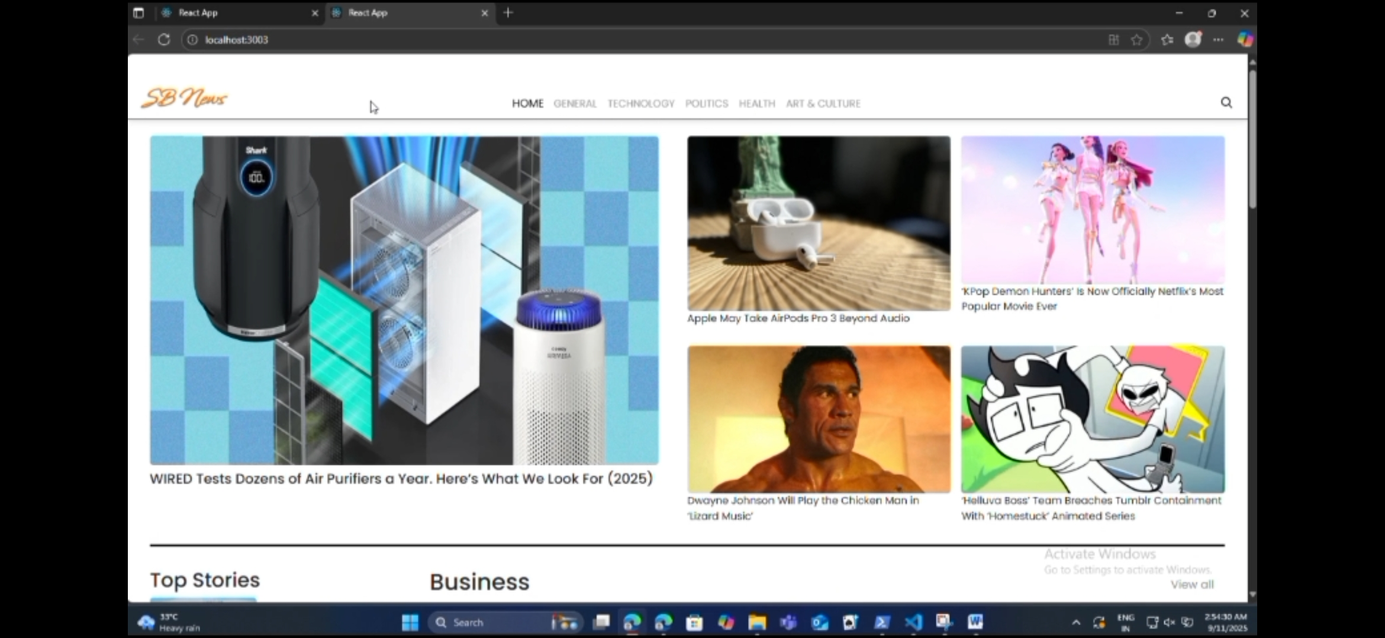

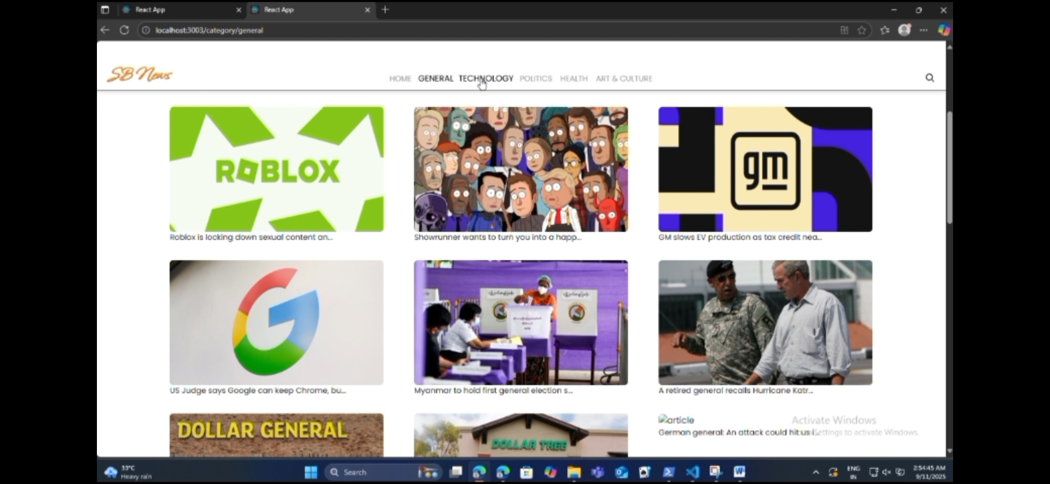

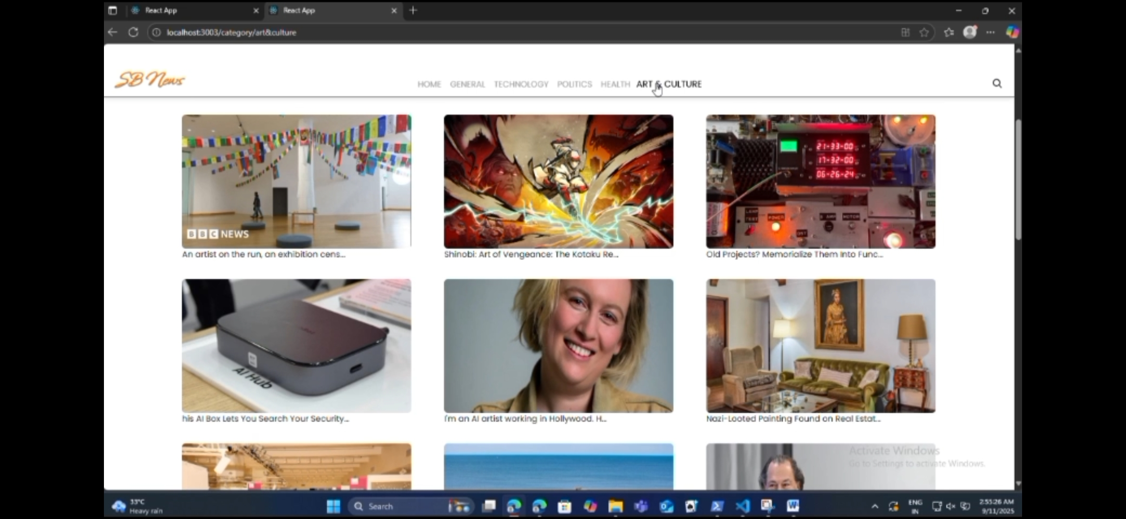

# 12. Known Issues

- Limited offline support  
- API rate limits may restrict data fetching

# 13. Future Enhancements

- Add authentication for personalized feeds  
- Allow users to save favorite articles  
- Implement dark mode toggle  
- Enable push notifications for breaking news